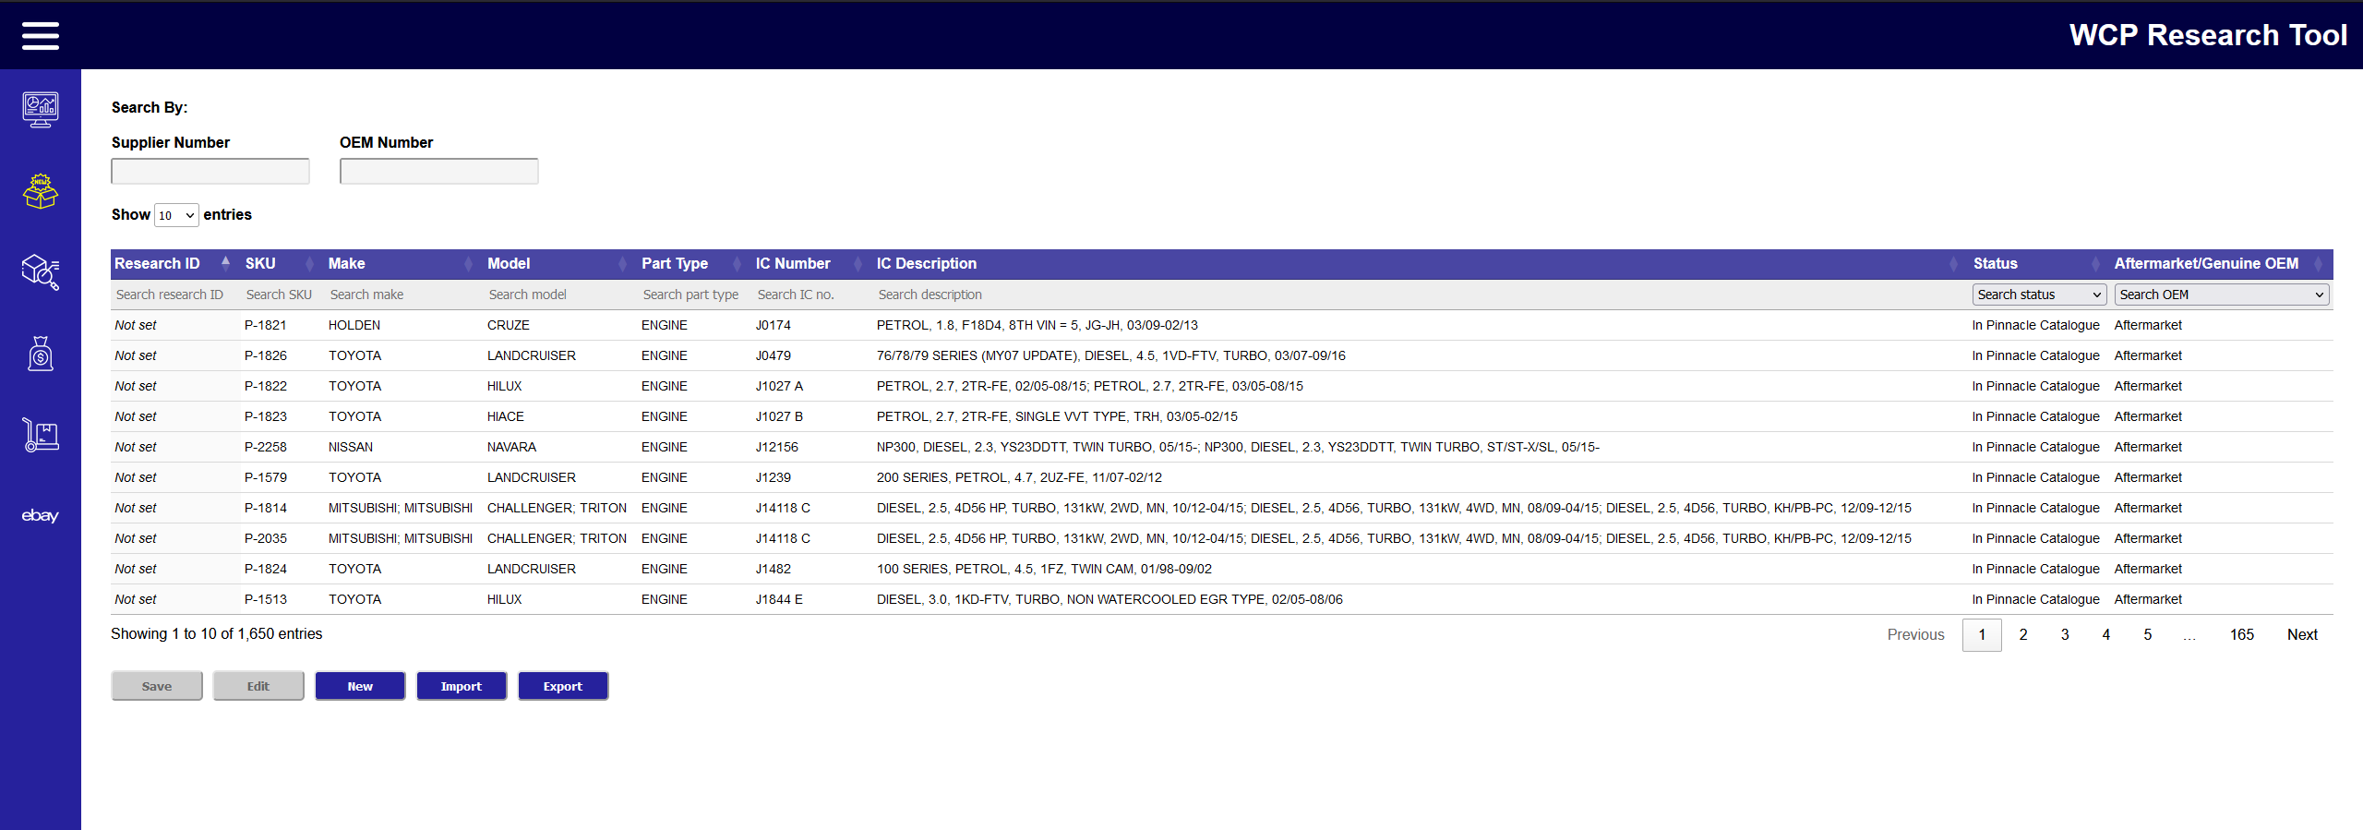``

Needs to imported by the User

Will be from API, but user can change



From API

From User input (AKA Manual)

Will be automatically assigned at first, but can be changed if not in Pinnacle Catalogue



Generated by Tool, if no SKU



From API

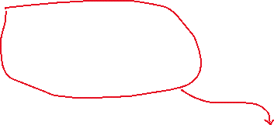

User import Data



Manual Input



Calculated, but can be edited.



Some Needs to import by the User, Some generated by tool based imported data, Some is manual Input from User

Based on Selection

